

2015 Goldstein Award for Excellence in Problem-Oriented Policing.
Lewisham Safer Transport Team, Metropolitan Police London.
‘Skitching’.

Summary
Scanning;
The problem identified was that youths on roller skates were holding onto moving vehicles. This activity was being done by boys and girls aged between 12 and 18 years in the carriageways throughout Lewisham Borough.
Analysis;
Bus Driver Incident Reports (DIRs) provided by Transport for London (TfL) indicated to us that the skaters were mostly holding onto the rear of London Buses. These buses were operating on some of the busiest roads through Lewisham such as the A21. This activity was causing bus drivers to stop their buses and wait for the youths to let go of the bus and move away - causing delays and congestion. The sight of youths on skates holding onto moving buses and other vehicles was causing alarm and distress to motorists who were reporting incidents to Police, which was reflected in the rise of Computer Aided Dispatch (CAD) calls for Police units to attend.
The problems faced were; Identifying why this activity took place, where it took place, when it took place, and how to police the problem safely and efficiently.
From the outset, it was agreed that there was an immediate need to tackle this problem which was putting every road user in danger, with potentially fatal consequences - before a serious injury or a fatality occurred.
Response;
From the outset it was decided that we must work in partnership with TfL, Lewisham Council, and Local Schools to help us tackle this multi-stakeholder issue.
We explored the option of using The Road Traffic Act as a means of solving the problem, however we all felt that this avenue would not be preventative and would unnecessarily criminalise children where educating them would be the smarter option with longevity.
Using funds that we applied for from TfL we were able to hold a Skate Safe Campaign focused on education.
Assessment;
We initially achieved a 66% reduction in the problem, rising in 2015 to a 100% reduction in the problem. Most importantly - there were no serious injuries or fatalities on the streets of Lewisham as the result of Skitching activity.

Description:
Scanning;
Skating in the carriageway and holding onto moving vehicles - or Skitching as it became known as was initially highlighted to Lewisham Safer Transport Team by the Transport for London Community Safety, Enforcement and Policing Team (CSEP) who had identified the emergence of DIRs where bus drivers were experiencing delays due to Skitching activity. This information complimented an emergence of CADs relating to members of the public calling Police about Skitching activity.
The problem was initially not being managed by Police or any other agency. It was treated as a ‘business as usual’ occurrence. The problem was completely new to the London Metropolitan Police District.
Due to the number of Driver Incident Reports for this unique trend, Lewisham Safer Transport Team were asked to look at this problem by TfL
The first aim that Lewisham Safer Transport team set was to prevent a serious injury or fatality due to skitching activity.
The secondary aim was to reduce the problem by at least 30% which was arbitrarily chosen as a target to strive for. It was recognised that by striving to achieve the first aim through education, enforcement and diversionary tactics, that the secondary aim would be achieved too.
Skitching activity was affecting all road users; Buses were being delayed causing disruption to Passengers, Bus Drivers had to be wary of Skaters - periodically checking that they did not have Skaters holding their bus - and generating further Incident reports for the benefit of other drivers when they saw Skaters in the Carriageway. Other motorists driving private and commercial vehicles were also experiencing incidents of Skitching. There was only one linked / other reported incident of damage caused when Skaters lost control of their skates and collided with parked vehicles, there were no serious injuries.
Luckily Lewisham Safer Transport Team began dealing with this problem from a proactive standpoint, rather than reactively - for example following a serious injury etc. Thus, the actual victim(s) were the delayed motorists, Bus companies or travelling passengers. The very real potential for a serious casualty as the result of a road traffic accident due to Skating activity was a genuine incentive to act swiftly.
The offenders were identified as being both males and females aged between 12 to 18 years. These offenders were described as such by both bus drivers and members of the public. The locations for these offences were on roads with a bus route, predominantly the A21 (a major arterial route into London) and Lewisham High Street.
In late 2011 the Skitching problem emerged with 54 incidents of Skitching reported via Driver Incident reports between August and December. In 2012 the monthly driver incident reports were;
January - 24. February - 21. March - 16. April - 15. May - 28. June - 42. July - 33. August - 57. September - 25. October - 22. November - 11. December - 15. Giving a total of 309 separate incidents in 2012.

Analysis:
Sergeant Buchanan checked The National Legal Database to confirm the legislation surrounding the offence of holding onto vehicles in the carriageway. The Metropolitan Police Traffic Policy unit was also contacted. They had no records of such widespread Skitching. It was also apparent that no policy existed for Police officers officers in dealing with this activity.
Research was conducted at Bus garages to discover how the skaters were holding onto the rear of the buses. Both single and double decked buses were looked at. It was discovered that the exposed fuel filler cap and the frame that holds advertisements on the engine cover were the only available points that a skater could use to grab onto. It was discovered that some buses did not have exposed fuel filler caps and the advertisement frames were very flat. These ‘sterile’ buses did not have reports of Skitching activity along their routes.
Constable Hathaway asked Bus drivers about their experiences of Skating Activity. Every driver said that it was a constant nuisance, and that they always stopped their bus as soon as they became aware that skaters were holding onto their vehicle where they would then wait until the skaters lost interest and moved away. The drivers confirmed that they did not have any special training on how to deal with this activity. When they were asked what they believed would help solve the problem, the majority of drivers said that they believed that the skaters were travelling to Skate parks where they would spend a few hours before travelling home. However because they were perhaps tired, did not have shoes, they would try to board the bus on Skates. Passengers are not permitted on buses wearing skates. The bus drivers spoken to believed that this lead to the skaters riding the bus ‘on the outside’ to get home. If the skaters had shoes they could change into, out of their skates they would be able to board the bus.
The National College of Policing was contacted to ascertain if this problem had been dealt with anywhere in the United Kingdom Previously. It was apparent that this was a new trend not previously policed.
Internet searches revealed that Exeter Police had dealt with Skaters holding onto vehicles, but further research revealed that this was an occurrence isolated to two youths which was policed effectively and ended when both suspects were arrested.
International research showed that New South Wales Police Australia had some sporadic issues with Skaters holding onto moving vehicles. The problem in New South Wales was limited to Skateboarders and ended after two arrests were made.
Safer Neighbourhoods Schools officers were asked to provide estimates of numbers of school pupils who skated to school. At some schools, 30+ pupils were skating to school.
The two largest stockists of Skates, and skate related merchandise in south east London were contacted. They informed us that their sales of the classic ‘Quad’ (as opposed to in-line) skates were higher than ever before.
It was discovered that in Lewisham Borough there are three skate parks. Each Skate park is located inside a public park. None of the skate parks have any lighting. The most popular Skate Park at Telegraph Hill was closed each day at ‘about 8 O’clock’. This lead to further issues where skaters would jump the fence to skate.
It was discovered that the most frequent Skitching activity was on major roads linking all three skate parks.
On speaking to Lewisham council, who were keen to become a partner, they informed us that Ladywell Youth Village had a regular attendance of youths who always arrived on roller skates. This youth club was visited and youths on skates were asked about skating in the carriageway and holding onto vehicles. It was quickly apparent that they did not realize how dangerous the activity was - or even that it was illegal.
As the Driver Incident reports showed, the peak time for incidents Skitching were between 16:00 and 19:00 with the majority, (11) occurring at 18:00, this appeared to coincide with school finishing times. The peak weekdays were Tuesday and Wednesday and the peak weekend day was Saturday. Overall the most incidents occurred at 16:00 on a Saturday. 24% incidents were in Lewisham High Street. The problem was otherwise spread across the whole borough.

Response:
To tackle the problem by identifying how to deal with it from a general policing perspective - we established that Skitching is an offence;
“Holding onto a motor vehicle / trailer in motion“, Contrary to Section 26(1) of the Road Traffic Act 1988 and Schedule 2 to the Road Traffic Offenders Act 1988. This information was passed to officers likely to have to deal with Skitching activity.
Policing the problem (on the street) was risk assessed by Constable Hathaway who explored the dangers involved to all parties that might present themselves when police identify an offence and try to intervene. For example - it was immediately apparent that Police Officers in marked Police vehicles driving up behind a bus with sirens blaring, to arrest a skater could have disastrous consequences for everyone involved.
To discover if any Police policy was already in place that could be implemented in Lewisham, the Metropolitan Police Traffic Policy unit was consulted, but being a new policing problem to the Metropolitan Police, there no such policy in existence.
In Lieu of this Constable Hathaway drafted a local policy which can be summarized as a ‘silent follow’, without lights or sirens, at a safe distance so as not to cause undue alarm to any party - with instruction to only attempt to stop and apprehend the Skater once the vehicle they were holding onto had come to a full stop. Officers were instructed to initially use the law to stop the problem, arresting if necessary. If arrest was not necessary Officers were asked to consider taking the youths home if they did not have shoes or other footwear, (when Police Officers believed they would continue to skate dangerously if they were left alone) this practice had the obvious benefit of removing the skater from harms way, and the benefit of informing the skaters’ parents of their conduct.
This local guidance was circulated to all London Safer Transport and Borough Policing teams. This local policy was later approved by the Metropolitan Police Traffic Unit and accepted as London - wide policy.
Sergeant Buchanan then produced a pocket book sized aide memoire containing legislation, Policy and advice when dealing with Skaters which he distributed to his team.
To compliment actions being undertaken by police, Constable Hathaway next approached the London Bus companies who operate buses in Lewisham under contract with Transport for London. Sergeant Buchanan and Constable Hathaway held impromptu surgeries in the Bus garage canteen where they were able to speak with the drivers, and their local health and safety representatives to convey advice that bus drivers should bring their bus to a safe and smooth stop as soon as they realize that skaters are on their bus, and only resume their journey once they were absolutely sure that the skaters had gone. Sergeant Buchanan also warned bus drivers that by ignoring the problem, and continuing to drive while skaters were holding onto their bus - that the bus driver would be committing the road traffic offence of allowing / permitting the holding offence. On the success of this surgery - Police Community Support Officers from the Safer Transport Team visited other bus garages to convey the same advice.
The next step taken was to arrange a meeting with Transport for London to explore the option of swapping certain buses to design out the problem. This, as previously discovered was because some buses had no hand holds that a skater could grab, while other buses made it very easy to hold onto them. The question was also raised by Constable Hathaway about the potential for a small sticker which could be placed in plain view on the back of the bus, near the favoured hand holds which would warn of the dangers of Skitching, and also point out that it was an illegal activity. Due to contractual issues neither of these ideas became a reality.
Constable Hathaway then printed 2000 leaflets which he designed to educate skaters, containing road safety advice, it informed skaters that Skitchers could be arrested if caught, and that they would lose their free travel - which could cost their household up to £500 a year in travel costs. The leaflet also included a map and information about Skate Parks and forthcoming events in Lewisham borough.
The chosen delivery method for these leaflets was via the two largest Skate and Skateboard stockists in Lewisham - FINCHES and URBAN CHAOS. These outlets were identified as being credible to Skaters - with less chance that the leaflet would be instantly dismissed. Both retail outlets agreed to place a leaflet in a customers bag with every single skate related purchase, from wheel bearings, to skate laces, no matter the age of the customer. As well as directly educating the skaters, this method also provided an opportunity for the parents of young skaters to see that Skitching had become a safety and police concern, the intent being that Skate safe education would also come from parents of skaters.
Officers from Lewisham Safer Transport team also distributed these leaflets to Skaters at every opportunity in the street. Safer Schools officers were also asked to distribute them to school pupils who skated to school.
Sergeant Buchanan established links with Lewisham Council, who had also recognized that Skating had become hugely popular in Lewisham. Together with other partners from the Lewisham Street Wardens, Lewisham Youth Services/ Clubs, and the Road Safety Team, they formed a new venture called ‘Skate Safe’, with the simple aim of educating youths in Lewisham about the dangers of skating in the carriageway, with their goal being to prevent serious injury or a fatality on Lewisham’s roads of any road user, as a result of Skating activity.
Constable Hathaway worked with Lewisham Council to produce a ‘Skate Safe Campaign’ flyer. He helped with the wording of legal advice - to cut through legal jargon, while Liz Fowler; the Lewisham Council Community Safety Officer sought advice from youths living in Lewisham over the design and content. (See Appendix, Image 1)
Sergeant Buchanan and Pc Hathaway had further meetings with Transport for London regarding Skaters and how to punish them for reckless activity and try to promote road safety. Transport for London agreed to remove the free travel Zip Oyster Card privileges for youths caught skitching. This became an important message that we fed to schools and parents via Twitter in the hope that this would incentivise parental control of the problem - ‘Zip’ Travel cards were part of a government incentive to encourage youths to use public transport - thus decreasing the amount of school-run traffic, and easing traffic congestion in London. The approximate savings per household are thought to be £2000 a year. The Skater would then in turn be offered the chance to enter into the Skaters Acceptable Behaviour Agreement (ABA) which had been drawn up by Sergeant Buchanan and Lewisham Council. The requirements of the agreement were; 1) do not skate in the Carriageway, or otherwise come to Police notice for a period not less than three months. 2) Attend a Skate Safe Workshop. To enter the ABA, the youth’s parent(s) or guardians would also be invited to sign the agreement - again in the hope that education and extra incentive would come from home; the agreement would also be signed by a member of Lewisham Safer Transport Team and Liz Fowler, from Skate Safe.
Liz Fowler is responsible for forming the Skate Safe Campaign. She chaired regular meetings and began to focus Lewisham Council resources and attention at the Skitching issue. The skate safe campaign was widely publicized, featuring prominently on the Lewisham council website, and also the ‘young’ Mayors program web pages called B-Involved, an established scheme in Lewisham aimed at promoting youth interaction with the local authority.
Bi-monthly Skate safe meetings were chaired by Liz Fowler at Lewisham Council offices, where it was agreed that the Skate Safe Campaign would host a ‘Skate Safe Workshop’ at the Ladywell Fields Village, an established community centre which is funded by Lewisham council. This venue was chosen because it was already frequented weekly by a large number of youths who skate, and was an established premises with council Risk Assessments in place, which were easily supplemented with a Police Risk assessment covering the intended activity.
To pay towards the cost of holding a workshop Sergeant Buchanan successfully applied to Transport for London for a Safer Travel Initiative Grant to cover venue fees. Posters were designed and distributed across the borough at youth clubs and school. (See Appendix, image 2).
Prior to the Skate Safe Workshop - Constable Hathaway sent a letter to every youth in Lewisham who had come to police notice for Skating, and every youth who had had their free travel Oyster card removed.
On Saturday 16th February the Skate Safe workshop was held. The day was run on a ‘round robin basis’ whereby every youth who attended received input from stalls set up by;
• Constable Hathaway - where youths were spoken to about the legality of Skitching, the road safety team,
• Lewisham Skate Safe - on how to dress for Skating where they could skate,
• Professional Skaters who gave youths attending Skate Skills lessons
• ‘Doctor Skate’ a Lewisham Council funded enterprise where youths were able to have their skates serviced and maintained free of charge by a professional. In total 237 youth Skaters attended the Skate Safe Workshop. Each attendee was given a high-visibility snap band that they could wear on their person, a high visibility ‘tote’ bag that they were told to keep with them - so that they could skate with a spare pair of trainers in case they wanted to board a bus, a handy tool to assist them in maintaining their own skates, and some high visibility Skate Safe Branded Stickers for them to put on their skates, etc. (See Appendix, Image 3).
Two of the youths who had previously come to Police notice for Skitching who had been invited to attend the skate safe workshop successfully went through the acceptable behaviour agreement process and eventually won back their free travel by demonstrating good behaviour. One of these youths has volunteered to become a youth mentor, and the other is now employed at the Youth Centre, as a Skate co-coordinator.
The Skate Safe Team from Lewisham Council now has ownership of the problem of Skitching, they continue to offer free skating lessons and road safety advice. Lewisham Safer Transport Team remains a key partner.

Assessment;
The first and most impactive success that can be attributed to the Skate Safe Campaign is that no road users, pedestrians, or skaters have died, or have been seriously injured as the result of Skating activity in the carriageway in Lewisham Borough.
The Baseline figures for this problem were;
2012 DIRs;
January - 24. February - 21. March - 16. April - 15. May - 28. June - 42. July - 33. August - 57. September - 25. October - 22. November - 11. December - 15. A total of 309 separate incidents.
Using data available at time of writing, in 2013, the Driver Incident reports are;
January - 7. February - 6. March - 3. April - 7. May - 3. These figures reflect an average reduction in the number of Driver Incident reports of 66.2%, doubling the aim of a 30% reduction.
Using Driver Incident Reports, which are a reflection on the activity Pan-Borough these figures indicate that the problem has been dramatically reduced and not displaced to another part of the borough, or indeed, another surrounding London Borough.
It is also noteworthy that early 2012 saw Snow and heavy rail fall - but by comparison 2013 has had a very mild start to the year. That 2013 figures are so much smaller than recorded incidents in 2012 is hugely encouraging for the rest of 2013. (See Appendix, Graph 1)
The Skate Safe Campaign is a sustainable answer to the problem of Skitching. It has clearly not made the problem worse - and has smashed our early aim of a 30% reduction (which at the time we thought was an impossible task).
From its beginnings, this problem solving work has been conducted reactively. As such, it would be fair to say that it has not perhaps had the focus and attention that it may have enjoyed (or suffered) had our work begun under the spotlight following a fatality. 2012 also saw London under the gaze of the world as we hosted the Olympic and Paralympic Games, which can account for a lack of resources and funding that may have otherwise been available had this Skitching problem emerged in 2011. That said, with resources and finances stretched to the maximum - during an Olympic year we reduced the problem by well over half - without the loss of any lives on the carriageways in Lewisham due to Skating.
Lewisham Safer Transport Team, together with Skate Safe have been called upon to share best practice and organizational learning with other Police Operational Command Units in the Metropolitan Police - Bromley and Greenwich borough sought advice when the problem emerged there, albeit to a much lesser degree than seen in Lewisham.

Appendix

MONTH/ Yr | DIR's | MONTH/ Yr | DIR's | MONTH/ Yr | DIR's | MONTH/ Yr | DIR's
Jan-11 |  | Jan-12 | 22 | Jan-13 | 7 | Jan-14 | 0
Feb-11 |  | Feb-12 | 14 | Feb-13 | 6 | Feb-14 | 0
Mar-11 |  | Mar-12 | 12 | Mar-13 | 3 | Mar-14 | 0
Apr-11 |  | Apr-12 | 12 | Apr-13 | 7 | Apr-14 | 0
May-11 |  | May-12 | 33 | May-13 | 11 | May-14 | 0
Jun-11 |  | Jun-12 | 42 | Jun-13 | 7 | Jun-14 | 0
Jul-11 |  | Jul-12 | 33 | Jul-13 | 0 | Jul-14 | 0
Aug-11 | 3 | Aug-12 | 57 | Aug-13 | 0 | Aug-14 | 0
Sep-11 | 3 | Sep-12 | 25 | Sep-13 | 0 | Sep-14 | 0
Oct-11 | 17 | Oct-12 | 22 | Oct-13 | 0 | Oct-14 | 0
Nov-11 | 6 | Nov-12 | 11 | Nov-13 | 0 | Nov-14 | 0
Dec-11 | 25 | Dec-12 | 15 | Dec-13 | 0 | Dec-14 | 0
Graph 1. Skitching Incidents - recorded DIRs (TfL Data). 0 values reflect 0 incidents. A blacked out box reflects no data.

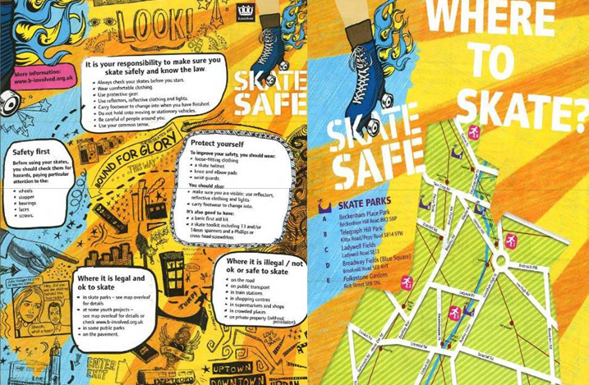
Image 1. Skate Safe Flyer

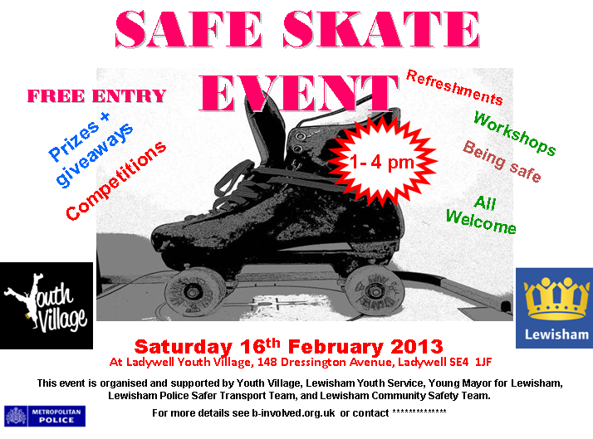
Image 2. Skate Safe Event Poster.

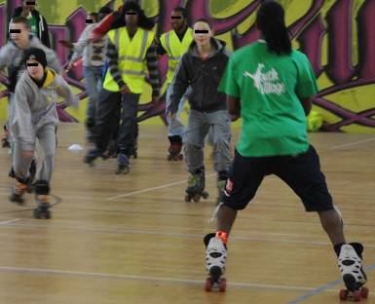
Image 3. Skate Safe Lessons at the workshop.

