Appendices

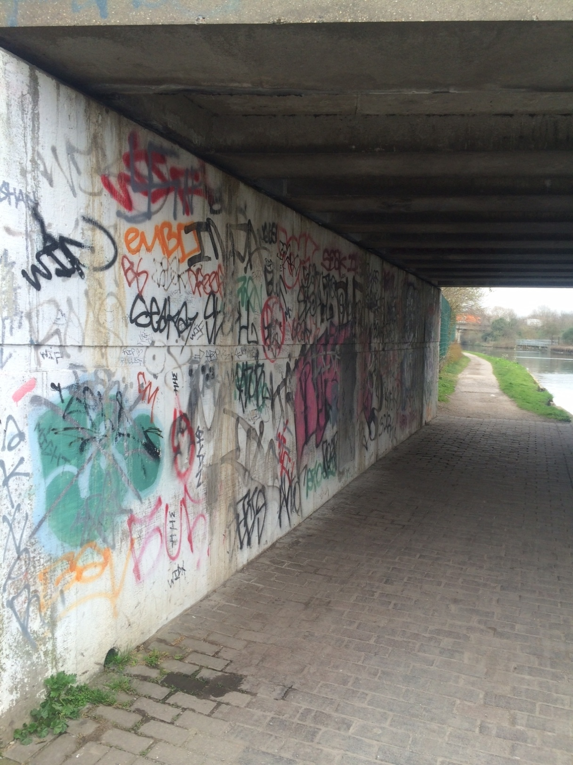 Fig1

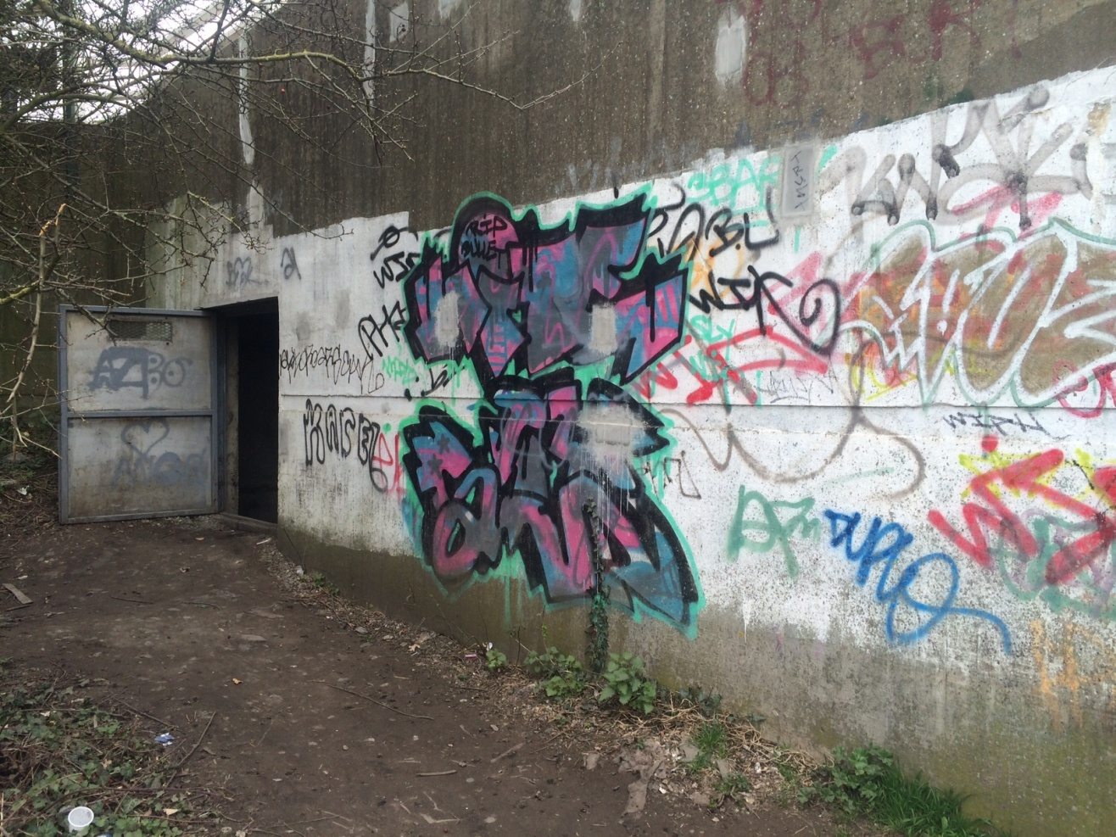
Fig 2

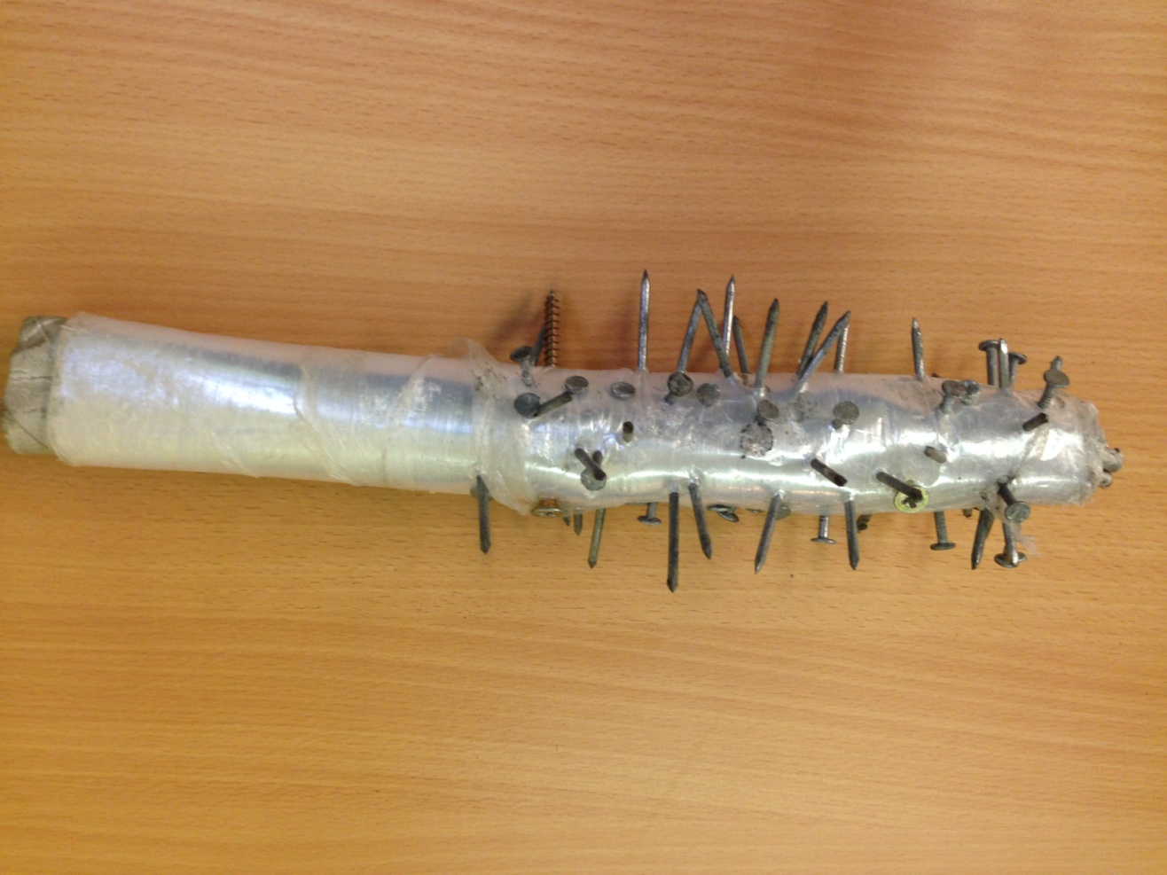
Fig 3

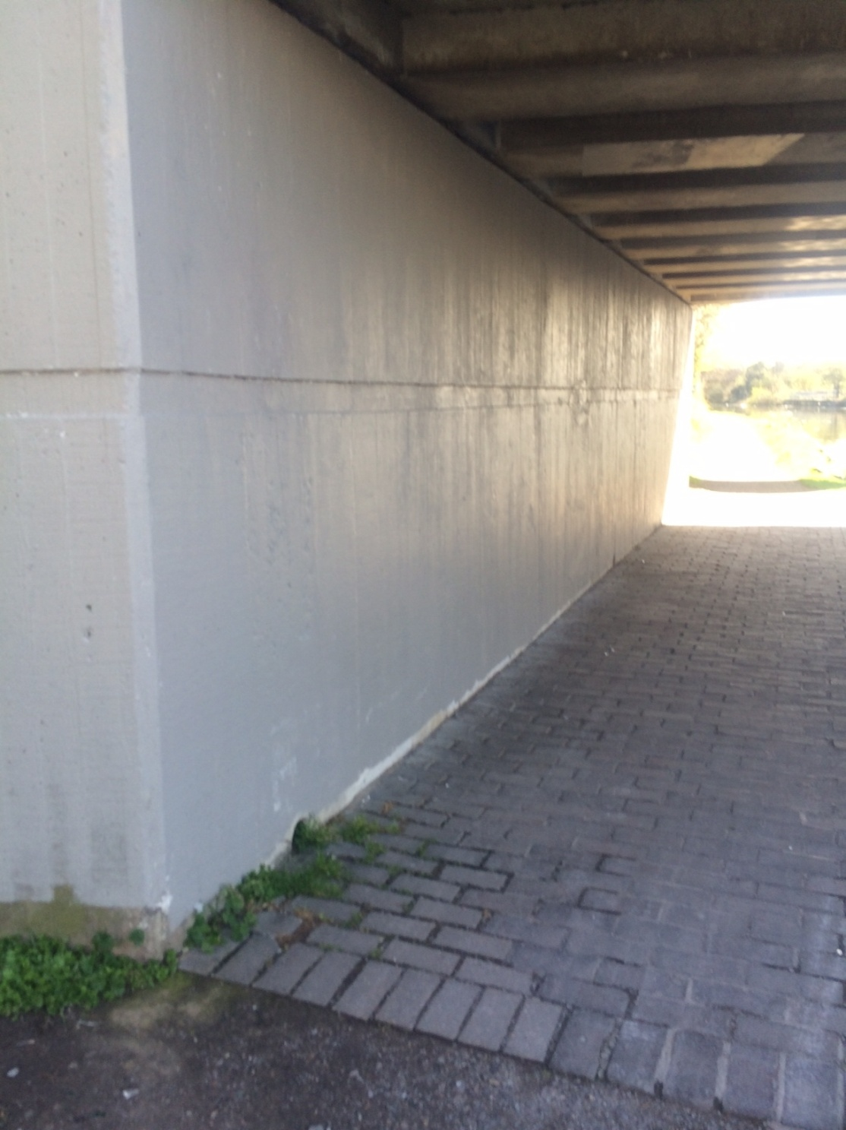
Fig 4

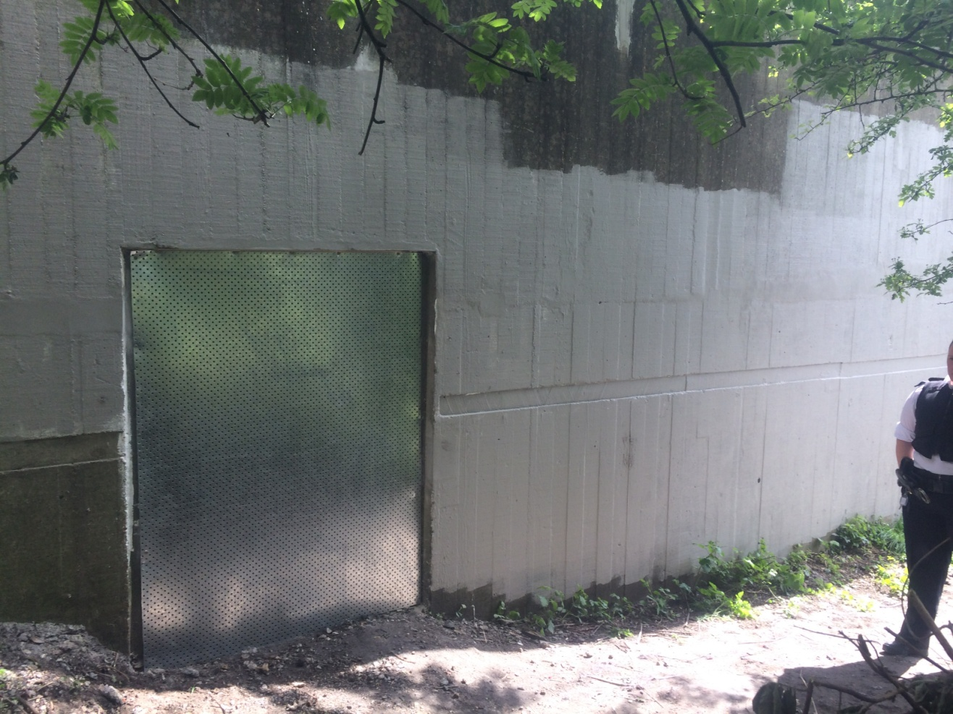
Fig 5

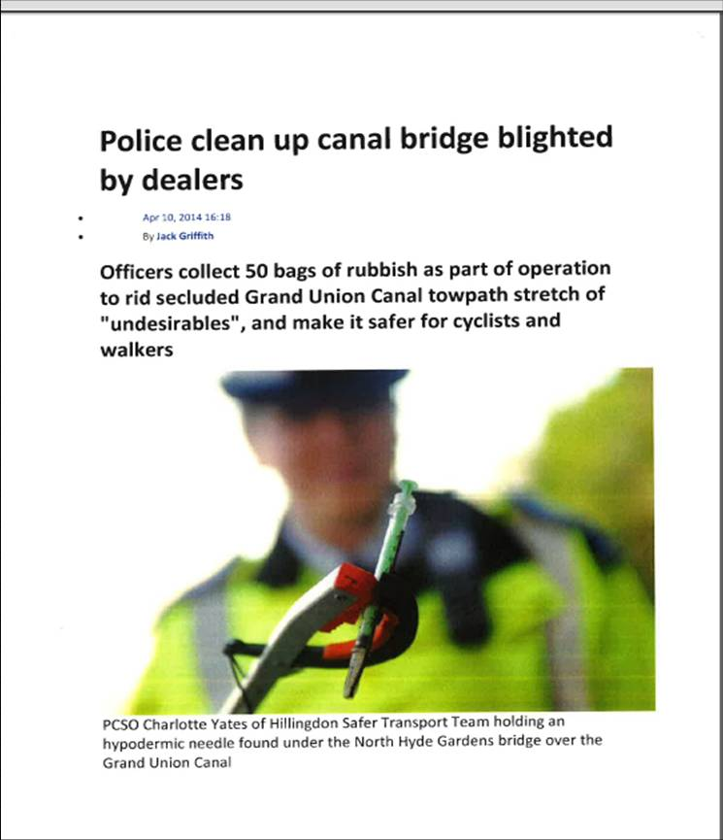
Fig 6

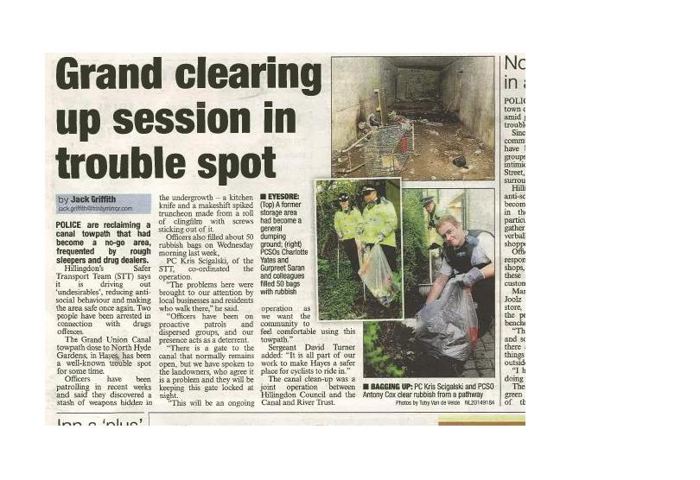
Fig 7

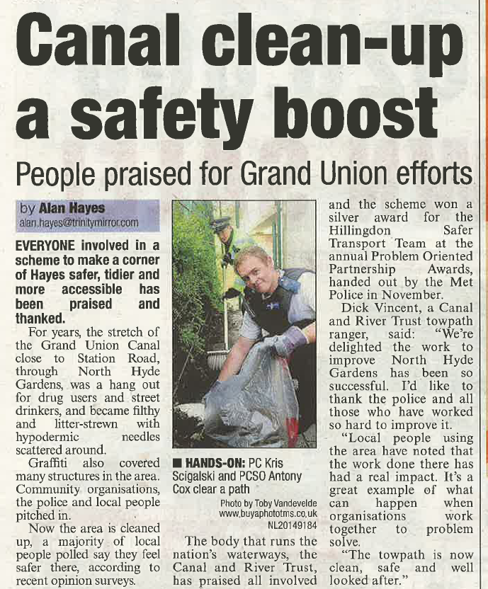
Fig 8

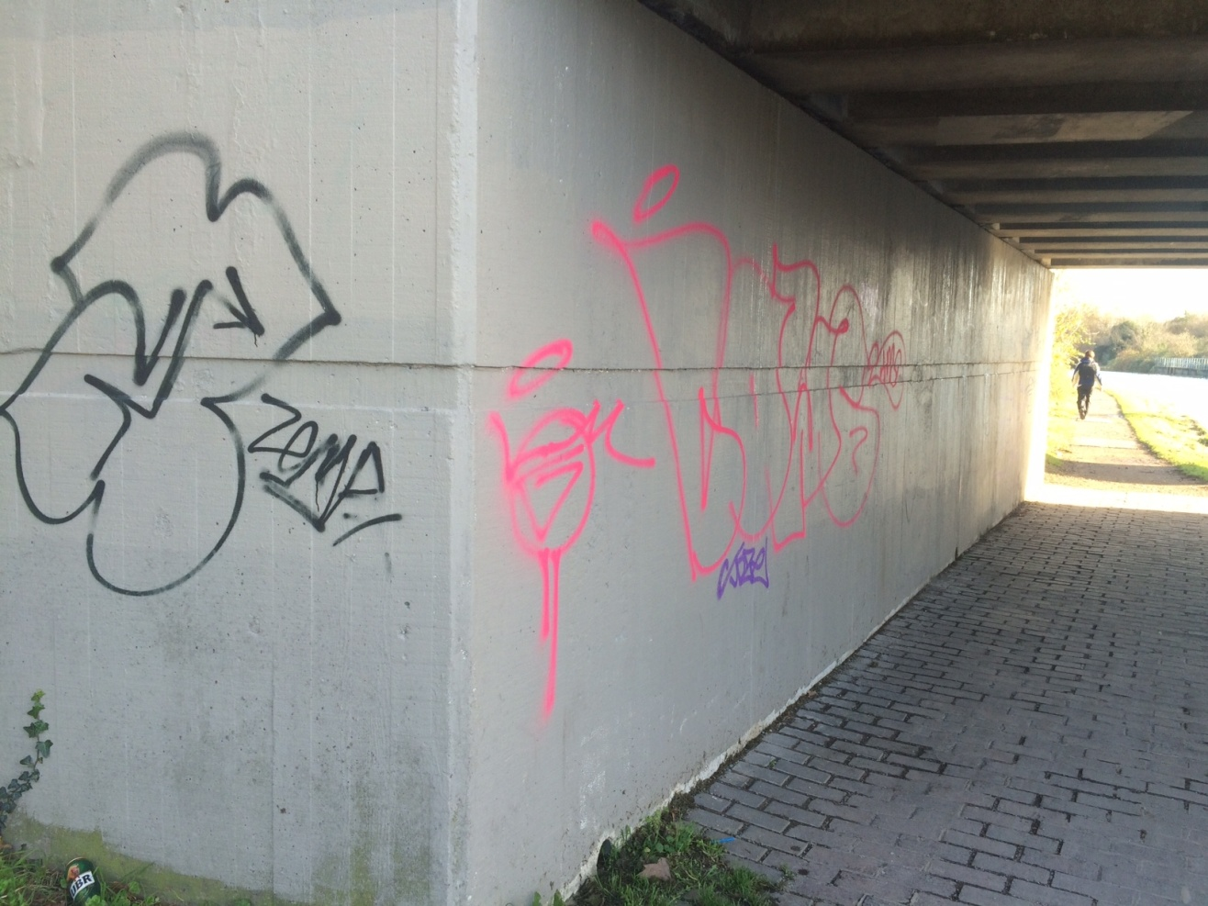

FIG 9

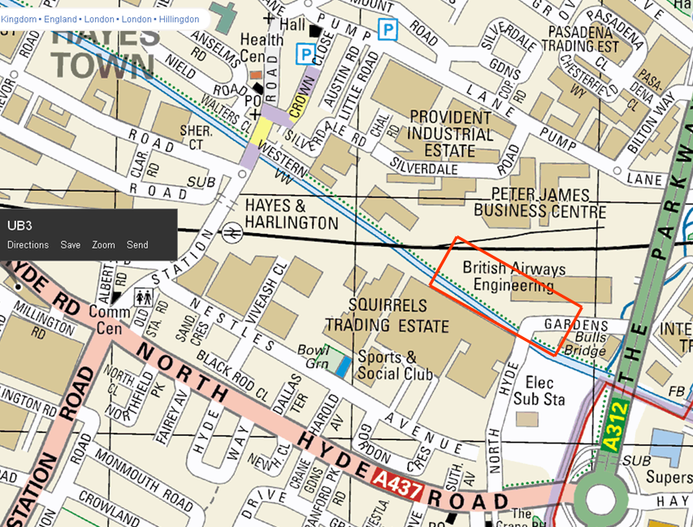

FIG10

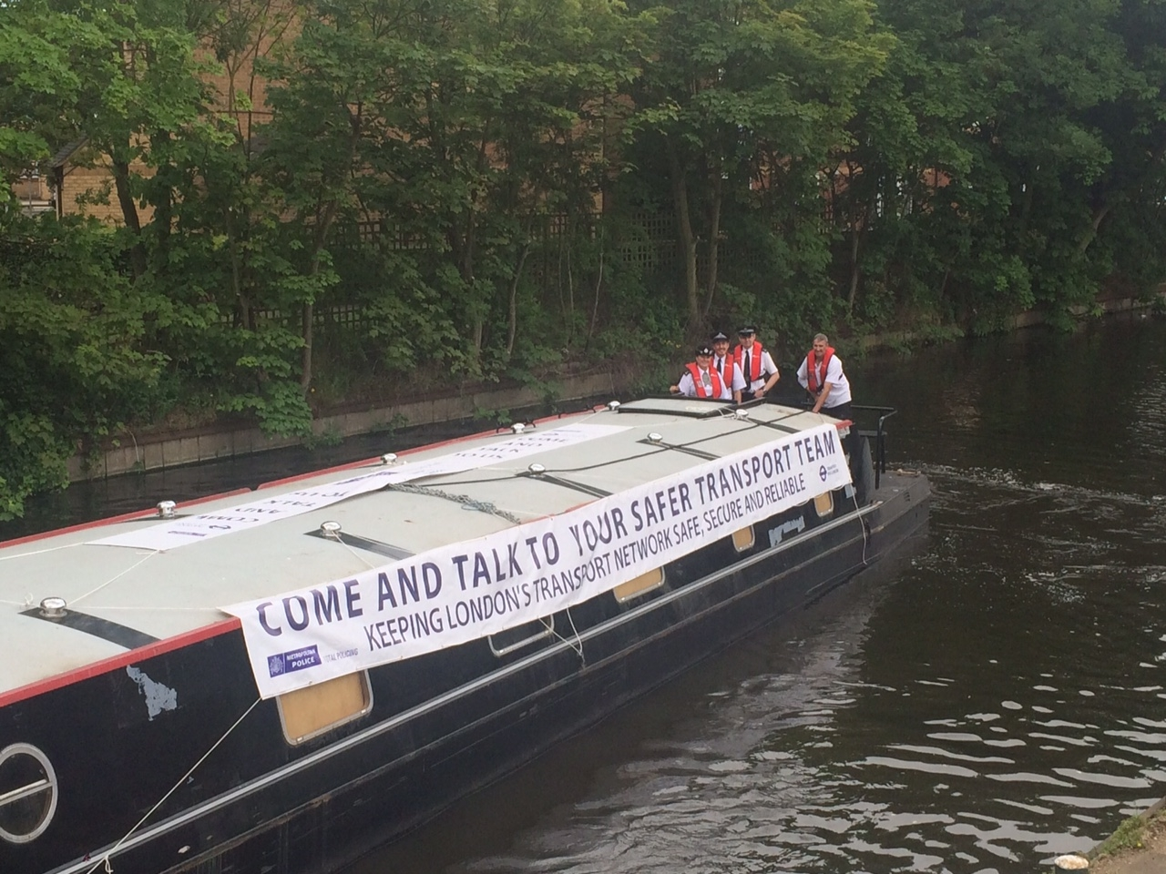

FIG14

Survey of 100 Canal Users (February 2014-April 2014)

Pre Intervention |  |  |  |  |  | Yes |  | NO
Do you feel confident/safe about using the canal tow path? |  |  |  |  |  | 10 |  | 90
 |  |  |  |  |  | AM |  | PM
What times do you feel unsafe? |  |  |  |  |  | 10 |  | 90
Are you worried about graffiti? |  |  |  |  |  | 85 |  | 15
Are you worried about drug taking? |  |  |  |  |  | 73 |  | 27
Are you worried about being robbed? |  |  |  |  |  | 93 |  | 7
Are worried about street drinkers? |  |  |  |  |  | 70 |  | 30
Are you worried about litter |  |  |  |  |  | 75 |  | 25
Do you regularly see police on the towpath? |  |  |  |  |  | 10 |  | 90
Are you confident about police actions on the tow path? |  |  |  |  |  | 15 |  | 85
FIG 11

Survey results (June 2014-September 2014)

Post Intervention |  |  |  |  |  | Yes |  | NO
Do you confident/ safe do you feel about using the canal tow path? |  |  |  |  |  | 75 |  | 25
 |  |  |  |  |  | AM |  | PM
What times do you feel unsafe? |  |  |  |  |  | 10 |  | 90
Are you worried about graffiti? |  |  |  |  |  | 15 |  | 85
Are you worried about drug taking? |  |  |  |  |  | 40 |  | 60
Are you worried about being robbed? |  |  |  |  |  | 55 |  | 45
Are worried about street drinkers? |  |  |  |  |  | 20 |  | 80
Are you worried about litter |  |  |  |  |  | 10 |  | 90
Do you regularly see police on the towpath? |  |  |  |  |  | 35 |  | 65
Are you confident about police actions on the tow path? |  |  |  |  |  | 70 |  | 30

FIG12

FIG 13

Do you feel confident/safe when using the canal tow path?
Pre-Intervention

Do you feel confident/safe when using the canal tow path?
Post-Intervention

 | Pre-Intervention |  | Post-Intervention
 | Yes | No | Yes | No
Do you feel confident/safe when using the canal tow path? | 10 | 90 | 75 | 25

KEY
Q.1 Are you worried about graffiti?
Q.2 Are you worried about drug taking?
Q.3 Are you worried about being robbed?
Q.4 Are you worried about street drinkers?
Q.5 Are you worried about litter?

 |  | Pre-Intervention |  | Post-Intervention
 |  | Yes | No | Yes | No
Q.1 | Are you worried about graffiti? | 85 | 15 | 15 | 85
Q.2 | Are you worried about drug taking? | 73 | 27 | 40 | 60
Q.3 | Are you worried about being robbed? | 93 | 7 | 55 | 45
Q.4 | Are worried about street drinkers? | 70 | 30 | 20 | 80
Q.5 | Are you worried about litter | 75 | 25 | 10 | 90

Do you regularly see police on the towpath?
Pre-Intervention

Do you regularly see police on the towpath?
Pre-Intervention

 | Pre-Intervention |  | Post-Intervention
 | Yes | No | Yes | No
Do you regularly see police on the towpath? | 10 | 90 | 35 | 65

Are you confident about police actions on the tow path?
Pre-Intervention

Are you confident about police actions on the tow path?
Post-Intervention

 | Pre-Intervention |  | Post-Intervention
 | Yes | No | Yes | No
Are you confident about police actions on the tow path? | 15 | 85 | 70 | 30

